

Functional Requirements Document (FRD)
  - Revelle Aesthetics – J938778

Copyright© 2018, Oracle and/or its affiliates. All rights reserved.
Any reproduction or distribution of any part of this document without the prior written permission of Oracle + NetSuite is strictly prohibited.
The information included in this document is confidential and proprietary information of Oracle + NetSuite.
Version: March 3, 2022

Oracle + NetSuite
2955 Campus Drive, Suite 100
San Mateo, CA. 99403-2511

Project Information
Implementation Name | Revelle Aesthetics Signup Customization
Customer Name (Number) | Revelle Aesthetics
Job Name (Number) | J938778
Document Owner | Brady Onkka
Project Manager | Brady Onkka
Lead Developer | Ilan

Document Version History
Rev | Date | Author(s) | Change Summary
1.0 | 10/09/2023 | Brady | Initial Draft

Table of Contents
1 Business needs 4
2 Impacted areas/modules [Optional as output] 4
3 Acceptance criteria 4
4 Solution proposal 4
5 Prerequisites 5
6 Assumptions 5
7 Constraints and limitations 5
8 Risks 5

Business needs
Revelle Aesthetics is looking for a solution to allow shoppers to create an account online for their teams to review and approve for orders. Before a shopper can be approved Revelle must review the new account, several critical pieces of information are needed, and they have requested we create a new page to contain these fields.

Impacted areas/modules [Optional as output]
This solution will require a creating a new custom page within My Account. This page needs to expose multiple fields from the customer record and allow customers to update the information in those fields.
We may also need to hide the existing MyAccount -> Settings ->Profile Information Page.

Acceptance criteria
Once a lead is created via the Login screen, a customer needs the ability to view and update the information available on this new page. Once updated Revelle will be responsible for reviewing and approving the customer for purchase, and place the initial order for the customer.

Solution proposal
Create a new section within My Account/update existing Profile page with the following fields.
Settings -> Profile Information can not be updated, since it’s SCMA.
Hiding “profile information” and adding this on a new view with additional fields mentioned will be much more work.
We propose instead, leaving Settings- > Profile Information section there and adding a new section which will be called “Additional Fields”.
Create a new section exposing the following fields, and including a block where text/instructions can be added:
- “category” field: allowing customer to view the list and select a new value from that list if needed. (List field)
- “thirdpartycarrier” field: allowing customer to view the list and select a new value from that list if needed. (List field)
- “thirdpartyacct” field: free form text with same id on customer record.
- “custentity_atlas_mfg_std_invoice_email” field: free form text.
- 2 Checkbox fields, one called Credit Card and the other Invoice. These 2 fields need to be created. If one is checked the other one will be disabled.
Up to here, this info has to be pre-loaded whenever entering the section if it has been already added before.

  - Create and expose 3 new fields:
      - Practice Manager (point Of Contact)
      - Physician
      - Accounts Playable
    - These fields are designed to allow a customer to enter the information that will allow Revelle to use the information later to create a new Contact.
    - Information that will be on these fields is name/email/phone, and they will be free form-text.
    - Explanation: We do not create contacts, we just get the info for example on “practice manager” and we send that into the custom field “practice manager” on the customer record.
    - Customer can put multiple emails, names and phone numbers on any of these 3 fields, meaning that there are multiple “Practice Managers”, or “Physicians” or “Accounts Playable”.
    - This does not need to be pre-loaded if it was added before.
- All fields should have the ability for the client to update the customer facing name. (I assume Translations) Give the customer the ability to translate the customer facing name via translations. Label it somehow that it’s unique. Using translations like this:
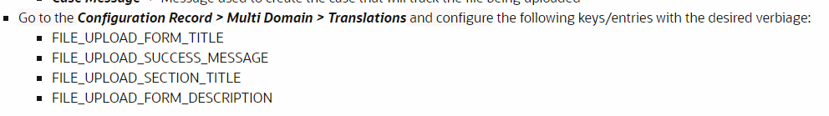
- Page should contain all fields currently displayed on Profile Information.
  - Possible addition is Company Name (field ID companyname)
  - Which other fields? (phone and email)
  - We will try to leave this section as it is, an add “additional fields” section without having to rework these fields and add them again, which will mean less hours.
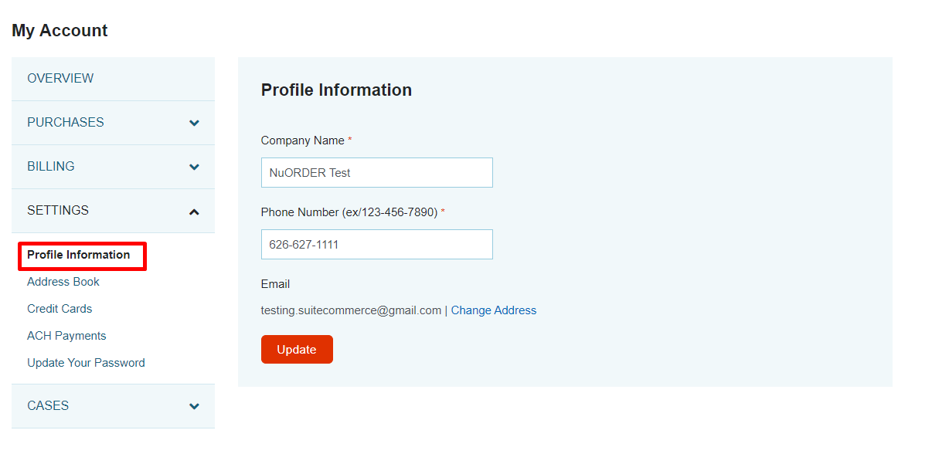
- Add an “Update” button which will save all the info filled up in the customer record fields.
- Not an empty form, load initial values. This will lead to much more work if we have to load everything.
- Instead of re loading values -> add a custom field on customer record, mark it if Additional Fields section has been filled up, and then charge on SCMA this field and check if marked, then hide this Additional Fields section. This would mean customer will not be able to edit the info he has already set on Additional Fields section.

Prerequisites

Assumptions
- The company/lead record will be created normally on the Register/login page.
- Any field exposed will be editable by all customers and not only at account creation.
- Revelle will be responsible for creating and maintaining their own alerts notifying them of new accounts/accounts being updated.

Constraints and limitations
- Anything not explicitly called out in this document is considered out of scope and would need another job.
- Use only available SuiteCommerce Extensibility component classes to customize the extensions.

Risks
- These changes could be broken by future updates. Additional work may be needed at that time to correct and fix this custom extension.
- If working with SCS and CSS rules are being used to achieve certain behavior then the theme could be updated in the future and the CSS rules might no longer work (although this is highly improbable the risk exists).

Oracle + NetSuite Professional Services and Customer are in agreement that the information documented above is accurate and representative of the customer’s business needs. This document will act as the basis for all subsequent implementation activities.
Document delivery date: MM/DD/YYYY

